 DEPARTMENT OF COMPUTER SCIENCE AND ENGINEERING

A MINI PROJECT REPORT

ON

**LEAD ACID BATTERY CHARGER**

*Submitted in partial fulfillment*

*for the award of Bachelor of Engineering in*

**ELECTRICAL &ELECTRONICS ENGINEERING**

Submitted by

**S.NO NAME USN SECTION**

1 Vishwanath patil 1NH18EE758 B

2 P.Muthahir 1NH18EE733 B

3 Venkan gouda 1NH18EE754 B

*DURING*

*ODD SEMESTER 2019-2020*

*For*

*19EEL38*

Reviewed by

Mr. SATISH KUMAR

(Department of EEE)

 DEPARTMENT OF ELECTRICAL &ELECTRONICS ENGINEERING

*Certificate*

*This is to certify that the mini project work titled*

**LEAD ACID BATTERY CHARGER**

*Submitted in partial fulfillment of the degree of Bachelor of Engineering*

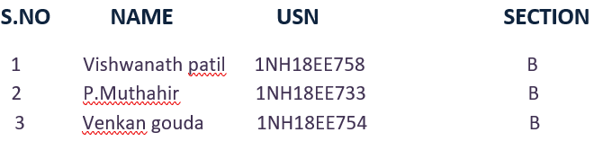

*DURING*

*ODD SEMESTER 2019-2020*

*For*

*19EEL38*

Signature of Reviewer Signature of HOD

SEMESTER END EXAMINATION

*Name of the Examiner Signature with date*

1._______________________ ______________________

2._______________________ ______________________

**ABSTRACT**

In this mini project we have designed working of various methods are investigated during the topic of the development of a smart charger for lead acid batteries. They contain constant voltage and constant current techniques, with extra to a method based on the estimated high number of cells and a couple of others based on the estimated high number of cells in the battery. The former two methods are well known. The estimated maximum and minimum methods are presented here. The minimum and maximum numbers of cells are calculated from the measured open circuit voltage. The most used and safest one involves determining the minimum number of cells in the battery and using this value to determine the charge voltage.

This method takes full advantage of the microprocessor capabilities of current chargers for diagnostic purposes and can be used to charge any size lead acid battery. The details of these methods and their merits and limitations are discussed

**TABLE OF CONTENTS**

**SL.NO CHAPTER TITLE**

**1 CHAPTER 1**

Introduction

**2**  **CHAPTER 2**

Literature survey

**3**  **CHAPTER 3**

Methodology

Components

**4 CHAPTER 4**

Circuit explanation & diagram

**5 CHAPTER 5**

Applications

Advantages & Disadvantages

**6 CHAPTER 6**

Conclusion & References

**ACKNOWLEDGEMENT**

The satisfaction that accompany the successful completion of any task would be, but impossible without the mention of the people who made it possible, whose constant guidance and encouragement helped us succeed.

We thank **Dr. Mohan Manghnani**, Chairman of **New Horizon Educational Institution**, for providing necessary infrastructure and creating good environment.

We also record here the constant encouragement and facilities extended to us by **Dr.Manjunatha**, Principal, NHCE and **Dr.S. Ram kumar** , head of the department of Electrical and Electronics Engineering. We extend sincere gratitude to them.

We sincerely acknowledge the encouragement, timely help and guidance to us by our beloved guide **Mr Satish kumar** to complete the project within stipulated time successfully.

Finally, a note of thanks to the teaching and non-teaching staff of electronics and communication department for their co-operation extended to us, who helped us directly or indirectly in this successful completion of mini project.

**Venkangouda -1NH18EE754**

**P.Md.muthahir khan -1NH18EE733**

**Vishwanath patil -1NH18EE758**

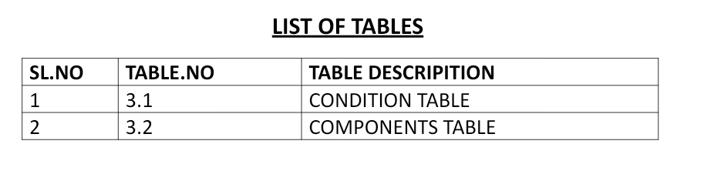

**CHAPTER 1**

**Introduction**

A I battery charger is a device used to put energy into a secondary cell or rechargeable battery by forcing an electric current through it

The charging process depends on the size and type of the battery being charged I . Lead acid battery has high I tolerance for I overcharging and can be recharged by connection to a constant voltage source or a constant current source, simple chargers of this type I require manual disconnection at the end of the charge cycle, or may have a timer to cut off charging current at a fixed time, the charger may have temperature or voltage I sensing circuits and I a microprocessor controller to adjust the charging current, determine the state of charge, and cut off at the end of charge I .

A charger works by supplying a constant DC power source to a battery I being charged. The simple charger does not alter its output based on time or the charge on the battery I . This simplicity means that a simple charger is inexpensive, but there is a little inefficacy in quality. Typically, a I simple charger takes longer to charge a battery to prevent severe over- charging . Even so, a battery left in a simple charger for too long will be weakened or destroyed due to over-charging I . These chargers can supply I either a constant voltage or a constant current to the battery. A very good example of this is the Lead-acid battery charger

**CHAPTER 2**

**LITERATURE SURVEY**

The research survey in the part of the battery diagnostics and prognostics identified three main parts. The construction of a battery model to repeat all the characteristics of battery behavior is the root step in understanding what one can do apparently for model-based diagnostics.

Therefore, a review of models was made. The estimation of state of charge remained a difficult task, and numerous attempts have been made to reliably construct a single method to do this.

Tough, a single estimation structure do not exist that works for all battery chemistries and applications. Therefore, are view of state of charge estimation for lead-acid batteries is included here. At last, it becomes important to understand how batteries age in automotive vehicles today. The natural aging and fault modes were inquest and reviewed.

**CHAPTER 3**

**METHODOLOGY**

A very simple battery charger circuit having reverse polarity indication is shown above. The circuit is based on IC L200. L200 is a five pin variable voltage regulator. The charging circuit can be fed by the DC voltage from the rectifiers. Here the IC L200 holds the charging voltage constant. The charging current is controlled by the parallel combination of resistors R2 and R3. The POT P1 can be used to reconcile the charging current. This circuit is designed to charge a 6/12 V lead acid battery. The transistor t1, diode D3 and LED are used to cause a battery reverse indicator. In case the battery is connected in a reverse polarity, the red LED D5 glows. When the charging process is going on the battery charring indicator green LED D4 glows.

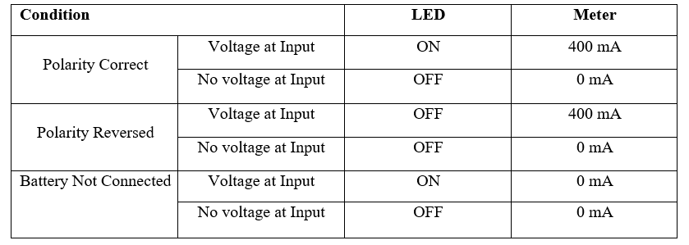

**COMPONENTS**

LED:

**A light emitting diode (LED)** is a two-lead semiconductor light source that equal a basic p n-junction diode ,beside that an led also emits light . When an LED’s anode lead has a voltage that is more positive than the cathode lead by at least the LED’s forward voltage drop ,current flows . Electrons are able to change with holes within the device ,releasing energy in the form of photons . This effect is called electroluminescence ,and the color of the light is unbending by the energy band gap of the semiconductor

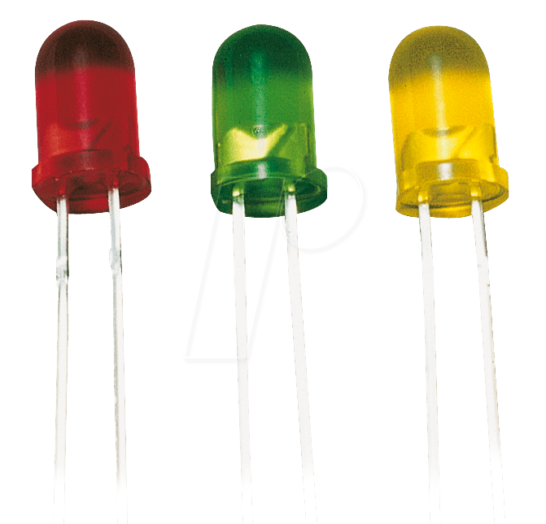

RESISTORS:

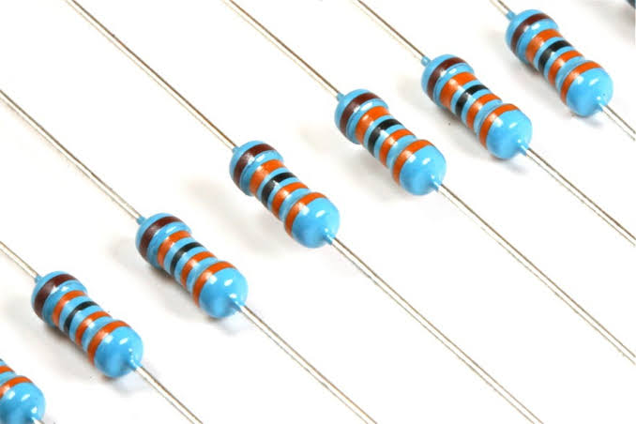

A resistor is a passive two-component electrical component that implements an electrical resistor as a circuit element. In electronic circuits, resistors are used to reduce current flow, adjust signal levels, divide voltages, bias active elements, and abort transmission lines, among other uses. High power resistors that can dissipate many watts of electrical energy in the form of heat can be used in motor controls, in power distribution systems, or as test loads for generators. Fixed resistors have resistances that change only slightly with temperature, duration or operating voltage. Variable resistors may be used to adjust circuit elements (such as a volume control or lamp dimmer), or as devices for detecting heat, light, moisture, force, or chemical activity.

Resistors are common elements of electrical networks and electronic circuits and are all over in electronic equipment. Practical resistors as discrete components may be composed of various compounds and forms. Resistors are also implemented in integrated circuits.

The electrical function of a resistor is specified by its resistance: common commercial resistors are manufactured in a range of more than nine orders of magnitude. The nominal resistance value is within the manufacturing tolerance specified in the component.

There are two connections which electrical components are connected within the circuit- **series** and **parallel**. They consists of different colour codes: BBROYGBPGW

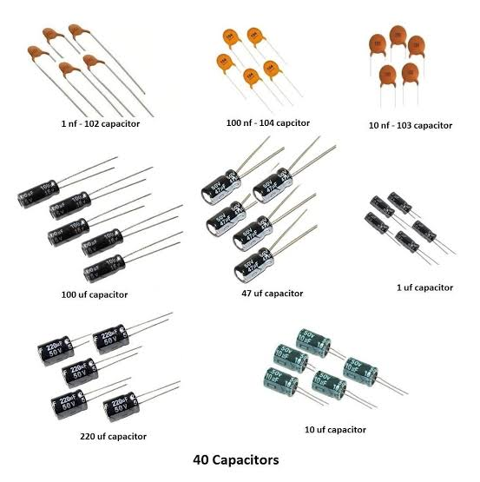CAPACITORS:

A capacitor is a device that stores electrical energy in an electric field. It is a passive electronic component with two terminals.

The effect of a capacitor is called capacitance. Although there is some capacitance between two nearby electrical conductors in a circuit, a capacitor is a component designed to add capacitance to a circuit. The capacitor was foremost known as a capacitor or capacitor. The original name is still widely used in many languages, but not fluently in English.

The physical form and construction of the practical capacitors vary widely and many types of capacitors are commonly used. Most capacitors contain at least two electrical conductors often in the form of metal plates or surfaces separated by a dielectric medium. A conductor may be a sheet, a thin film, a sintered metal bead, or an electrolyte. The non-conductive dielectric acts to increase the capacitance of the capacitor.

Commonly used materials such as dielectrics include glass, ceramic, plastic films, paper, mica, air and oxide layers. Capacitors are widely used as parts of electrical circuits in many common electrical devices. Unlike a resistor, an ideal capacitor does not dissipate energy.

When an electrical potential is applied, a voltage across a capacitor, for example when a capacitor is connected across a battery, an electric field develops across the dielectric, causing a net charge to accumulate on a base and a net negative charge. pick up on the other plate. No current actually flows through the dielectric. However, there is a charge flow through the source circuit. If the condition is maintained sufficiently, the current through the source circuit ceases. If a variable voltage is applied over time through the capacitor leads, the source experiences a DC current because of the charge and discharge cycles of the capacitor the device to external circuits or devices.

DIODE:

A diode is a two terminal electrical component that can conduct current in one direction as long as the diode operated in the specific voltage in reverse direction. the most common type of diode use as a pn junction. In this type of diode, in which (n) is electron charge carriers and second one (p)is holes (places depleted of electrons that act as positively charged particles)act as charge carriers a depletion region is formed across which electrons diffuse to fill holes p type. this stops the feature flow of electrons. When the junction is forward biased electrons can easily move across the junction to fill the holes, an a current flows through the diode. When the junction is reverse biased the depletion region widens and electrons cannot easily move across.

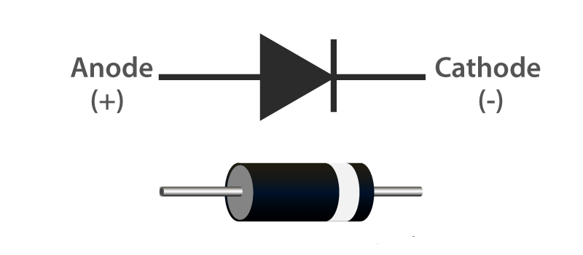

POWERSUPPLY :

A power supply is a device that supplies electric power to a electric load .The term is most commonly referred to electric power converts that converts one form of electrical energy to another ,though it may also refer to that convert another form of energy ( mechanical chemical, solar) to electrical energy . The regulated power supply is that controls the output voltage or current to a specific value ;the controlled value is held nearly

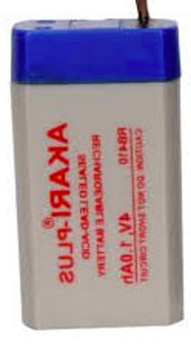

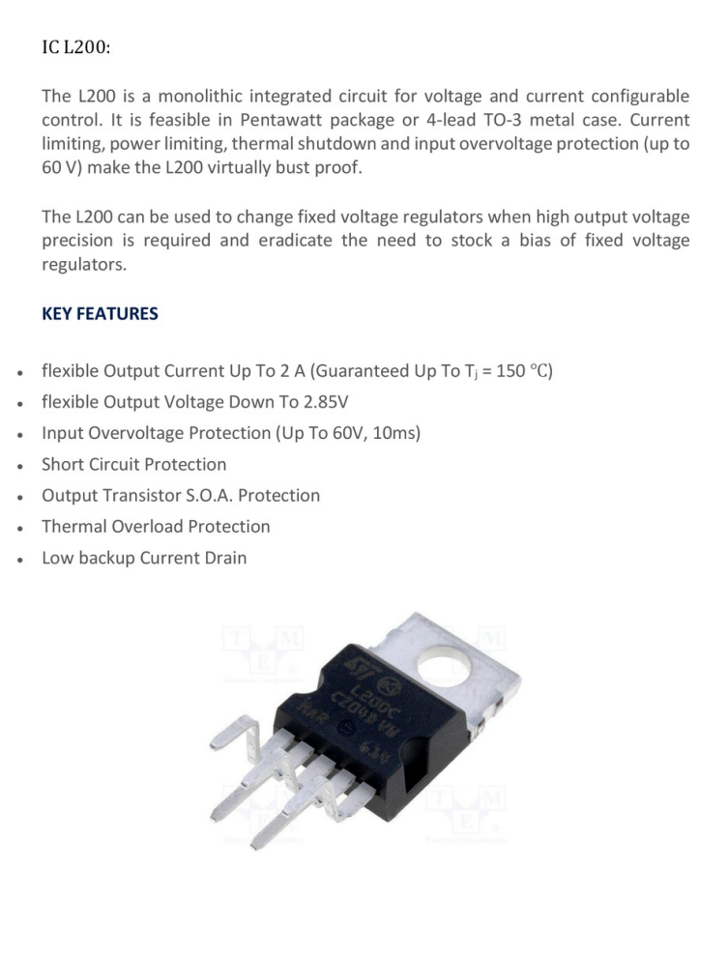

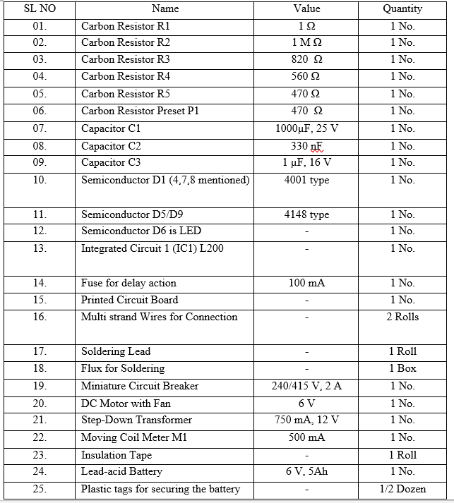

**CHAPTER 4**

**CRICUIT DIAGRAM & EXPLANATION**

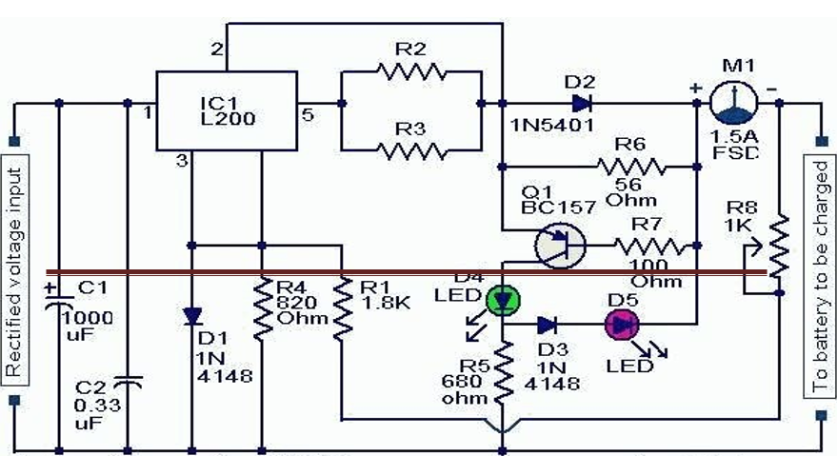

The IC L200 is being used in this project for charging a lead acid battery of 6 Volts. The IC L200 produces a good voltage regulation and therefore ensures a safe and a constant current charging, a necessity for any kind of chargeable battery.

The input supply is acquired from a standard transformer configuration, C1 forms the main filter capacitor and C2 being responsible for grounding any left residual AC.

The charging voltage is set by shaping the variable resistor VR1, with no load connected at the output.

The circuit involves a reverse polarity indicator using LED LD1.

**CHAPTER 5**

**APPLICATIONS**

* Automotive and Traction
* Standby/Backup/Emergency power for electrical installations
* Uninterruptible Power Supplies
* High current drain Applications
* Sealed battery types available for use in portable equipment
* Submarines

**ADVANTAGES**

* Robust, tolerant to abuse.
* Tolerant to over-charging.
* Low internal impedance.
* endless shelf life if stored without electrolyte.
* Wide range of sizes and capacities available.
* World’s most recycled product.
* Many suppliers world wide

**DISADVANTAGES**

* Dangers from chemical burns.
* Flammable gases while charging, or blow up and cause fires
* Batteries can be heavy.
* Electrolyte can evaporate.
* Cost more initially.
* Takes more time to charge the battery.
* Requires high maintenance.
* Require electricity and charger to recharge, can be recharged only from AC

**CHAPTER 6**

**CONCLUSION**

A simple lead acid battery charger system was portrayed successfully. The intent charger can work in constant voltage or constant current mode however constant voltage mode is the most chosen. The battery charger has many advantages like successful 3-stage charging, over charge protection, battery discharge protection and a simple design. Although the battery charger would be difficult to conduct in hotter temperatures. Further we can improve the heatsink to consume the heat better and also indicators can be designed to indicate heavy charge and float charge states.